Membership year paying ______________

Payment Date _____________

Check/Money order number ______________

Amount Submitted ______________

(US Funds Only)

*Indian Fantail Club of America Membership Application 2025*

*Annual memberships are due January 1st. Payments made*

*from Jan 1st Thru Sept 30th are paid for that current year.*

*Memberships paid Oct 1st thru Dec 31st are paid for the*

*current and following year. Memberships may be paid up to*

*three years in advance. Please Allow 3 -4 weeks for processing.*

*New Member Membership Renewal*

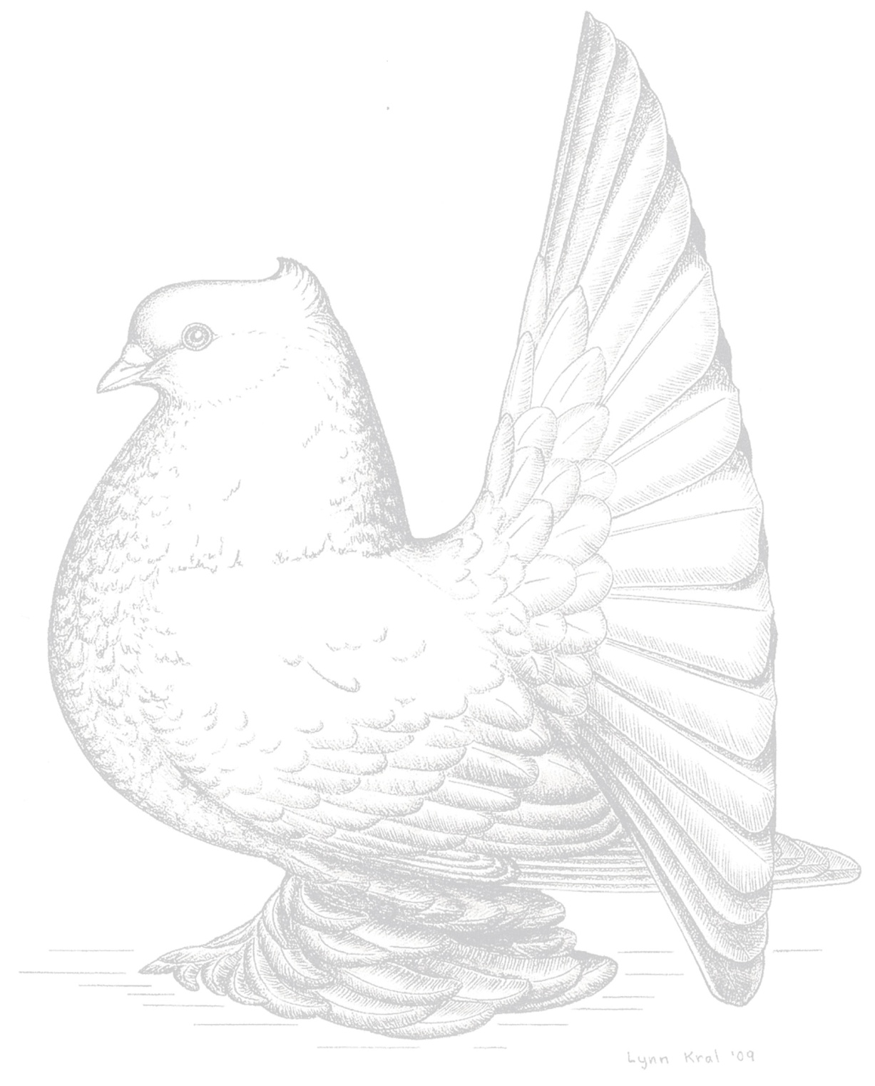

**First Name: Last Name:**

**Street Address:**

**City: State: Zip Code:**

**Area Code/Number: Email:**

*_________________________________________________________________________________________________________________*

***PLEASE PROVIDE TWO FORMS OF CONTACT***

Membership includes one Membership Directory every other year and quarterly Newsletters

Two voting ballots may be cast for Family Membership (providing two adult members over 17)

**Adult Membership** $20.00 for 1 year or $40.00 for 2 years $____________

**Family Membership** $25.00 for 1 year or $50.00 for 2 years $____________

**Junior Membership (under 17)** $5.00 for 1 year or $10.00 for 2 years $____________

**Please check here if you would like your Newsletter Mailed to you**

IFCA Specialty Bands: These are the official bands purchased by the IFCA from the National Pigeon Association and will be sold on a first come,

first serve basis, while supplies last. **A series of 25 bands minimum**. A current IFCA Membership is required in order to purchase bands.

**IFCA Specialty Bands (year 2025**) #___________ @ **$0.50 each** $_____________

Number of bands **MINDIANS SIZE 11**

#__________ @ **$O.50 each** $_____________

Number of bands **INDIANS SIZE 12**

**#___________________ @ $0.50 each**

Number of bands **INDIANS SIZE 13** $_____________

**Shipping cost for Bands (25 up to 100)** $ 6.00 ________

*Additional shipping costs apply for overseas members

**Additional Shipping for over 100 bands** $ 2.00 ________

**IFCA Patches** #_________ @ **$6.00** (includes shipping) $_______________________

Grand Total $____________

***The following questions, if answered, will be included in the Bi-yearly Membership Directory:***

**What year (roughly) did you start raising Indian Fantails? ______________________________**

**Would you be interested in becoming a future officer, judge or other position? Yes No Maybe**

Spud Peugh  
1872 Berry Lane  
Pleasant Garden, NC 27313  
[ifca.secretarytreasurer@gmail.com](mailto:ifca.secretarytreasurer@gmail.com)  
(336) 706-7144

**May we give your name to those inquiring to buy/trade Indian Fantails? Yes No**

**What colors and marks of Indian Fantails do you raise? __________________________________________________________________________________________**

**Make check or money order payable to IFCA and mail to:**